**DAILY ONLINE ACTIVITIES SUMMARY**

|  |  |  |  |  |  |  |  |
| --- | --- | --- | --- | --- | --- | --- | --- |
| **Date:** | **17/06/2020** | | | | **Name:** | **Amrutha G** | |
| **Sem & Sec** | **4TH&A** | | | | **USN:** | **4AL18CS006** | |
| **Online Test Summary** | | | | | | | |
| **Subject** | | **-----** | | | | | |
| **Max. Marks** | | **--** | | **Score** | | **--** | |
| **Certification Course Summary** | | | | | | | |
| **Course** | **Introduction to information security** | | | | | | |
| **Certificate Provider** | | | **GREAT LEARNING** | **Duration** | | | **6 HOURS** |
| **Coding Challenges** | | | | | | | |
| **Problem Statement 1: Write a C Program to Count numbers that don’t contain 3** | | | | | | | |
| **Status: executed** | | | | | | | |
| **Uploaded the report in Github** | | | | **YES** | | | |
| **If yes Repository name** | | | | **https://github.com/AMRUTHAGANESH/lockdown-certification_course**  **https://github.com/AMRUTHAGANESH/lockdown-codings** | | | |
| **Uploaded the report in slack** | | | | **YES** | | | |

**Online Test Summary:** NOT CONDUCTED.

**Online Certification course:**

Name of the course : Introduction to information security

Duration: 6 hours

Certificate provider: great learning

Snap shot:

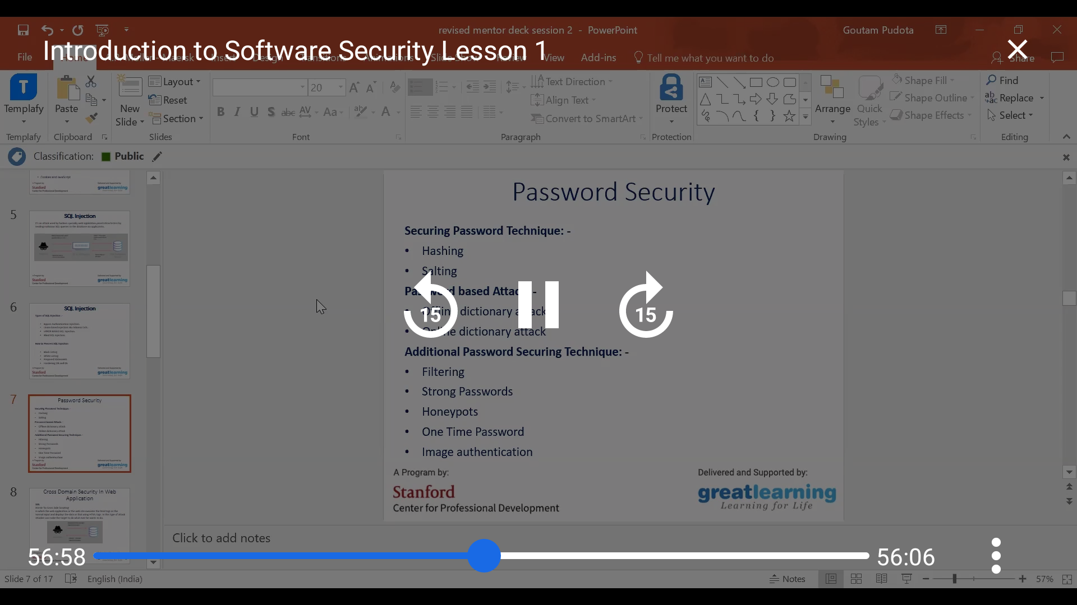

Today I go through introduction of information security lesson

Online Coding summary:

1.  **Write a C Program to Count numbers that don’t contain 3**

